**Access the nginx application from externally(browser) by using nodeport service in minikube:**

* First create ec2 instance on aws and update the server.
* Install docker,kubelet,minikube on server by using below commands and also download some packages and dependencies by using below commands.

To install kubectl

1 curl -LO https://storage.googleapis.com/kubernetes-release/release/`curl -s https://storage.googleapis.com/kubernetes-release/release/stable.txt`/bin/linux/amd64/kubectl

2 chmod +x ./kubectl

3 sudo mv ./kubectl /usr/local/bin/kubectl

# To install docker

4 sudo apt-get update && > sudo apt-get install docker.io -y

# To install minikube

5 curl -Lo minikube https://storage.googleapis.com/minikube/releases/latest/minikube-linux-amd64 && chmod +x minikube && sudo mv minikube /usr/local/bin/

6 sudo apt install conntrack -y

7 git clone https://github.com/Mirantis/cri-dockerd.git

8 apt install golang-go

9 wget https://storage.googleapis.com/golang/getgo/installer_linux

chmod +x ./installer_linux

./installer_linux

10 cd cri-dockerd

mkdir bin

go get && go build -o bin/cri-dockerd

mkdir -p /usr/local/bin

install -o root -g root -m 0755 bin/cri-dockerd /usr/local/bin/cri-dockerd

cp -a packaging/systemd/* /etc/systemd/system

sed -i -e 's,/usr/bin/cri-dockerd,/usr/local/bin/cri-dockerd,' /etc/systemd/system/cri-docker.service

systemctl daemon-reload

systemctl enable cri-docker.service

systemctl enable --now cri-docker.socket

11 VERSION="v1.24.1"

curl -L https://github.com/kubernetes-sigs/cri-tools/releases/download/$VERSION/crictl-${VERSION}-linux-amd64.tar.gz --output crictl-${VERSION}-linux-amd64.tar.gz

12 sudo tar zxvf crictl-$VERSION-linux-amd64.tar.gz -C /usr/local/bin

rm -f crictl-$VERSION-linux-amd64.tar.gz

13 VERSION="v1.24.1"

wget https://github.com/kubernetes-sigs/cri-tools/releases/download/$VERSION/crictl-$VERSION-linux-amd64.tar.gz

14 sudo tar zxvf crictl-$VERSION-linux-amd64.tar.gz -C /usr/local/bin

rm -f crictl-$VERSION-linux-amd64.tar.gz

15 sudo apt install -y containernetworking-plugins

16 wget https://github.com/containernetworking/plugins/releases/download/v1.2.0/cni-plugins-linux-amd64-v1.2.0.tgz

17 sudo mkdir -p /opt/cni/bin

18 sudo tar -C /opt/cni/bin -xzf cni-plugins-linux-amd64-v1.2.0.tgz

19 sudo sysctl fs.protected_regular=0

20 sudo minikube start --vm-driver=none

* Create the deployment file by using **vi filename.yml** command.

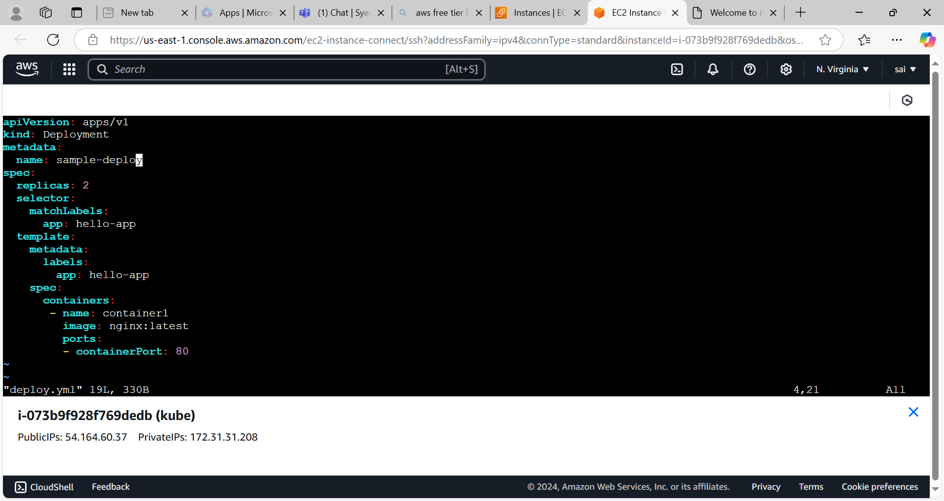

* Create the deployment by using **kubectl create -f filename**

Command.

* Create the service yml file 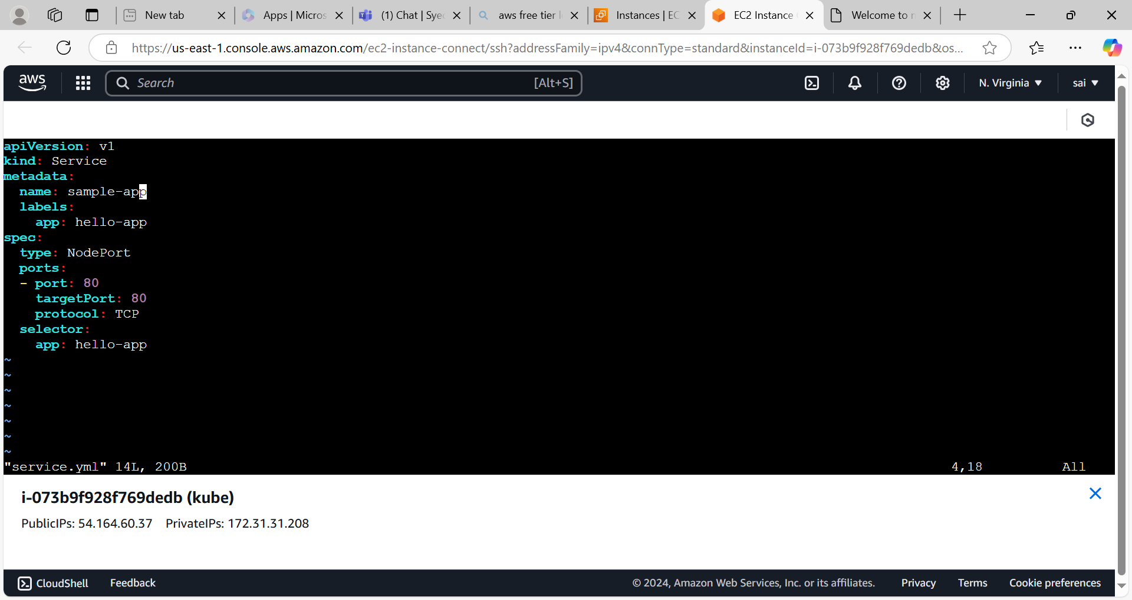
* Create the nodeport service.
* List the deployments,services

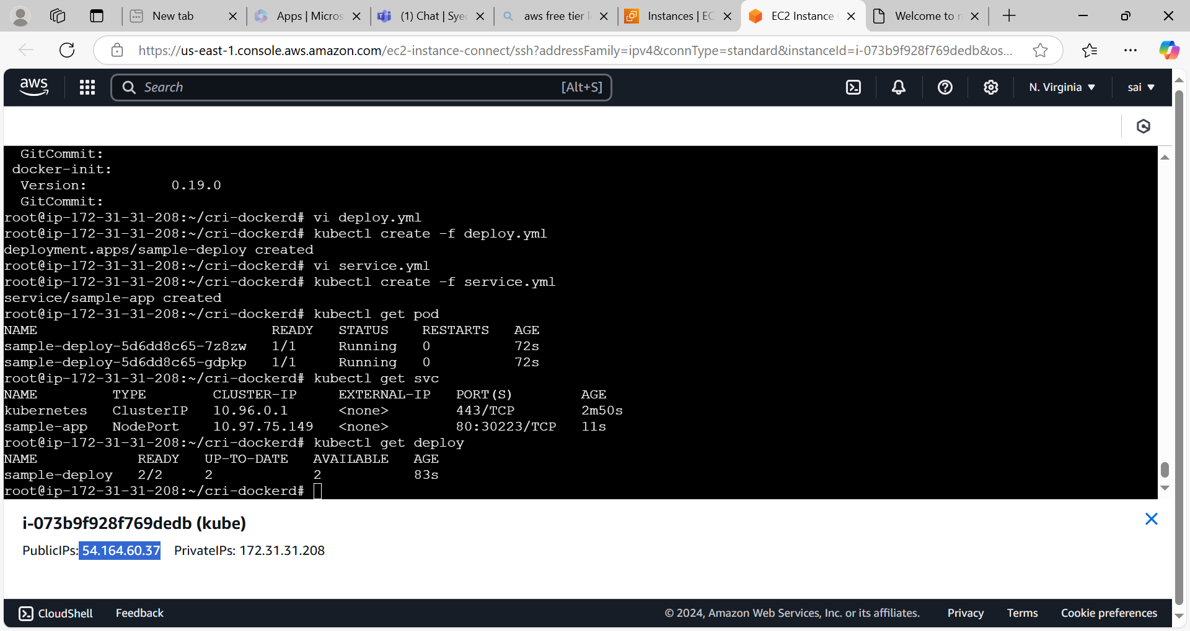

BY using public ip of ec2 instance with nodeport number we can access the nginx from the browser.